

# Product Dissection: PhonePe

## Github repo link: <https://github.com/Velprakash0611/Labmentix_Intern/tree/2d1eea21c99d274fde0615621485289c149bb565/Product%20Disection%20-%20PhonePe>

## Overview

**PhonePe** is a leading digital payments platform in India that facilitates online transactions through the Unified Payments Interface (UPI). Launched in 2015, PhonePe allows users to make instant money transfers, pay utility bills, recharge mobile phones, and conduct online shopping seamlessly. The app's user-friendly interface, high-security standards, and broad range of services have contributed to its widespread adoption, boasting over 300 million users across the country. As a comprehensive financial services provider, PhonePe also offers insurance, mutual fund investments, and personal loans, positioning itself as a one-stop solution for users' financial needs.

With a strong emphasis on customer convenience and security, PhonePe has become a trusted name in digital payments. It competes with other major players like Paytm, Google Pay, and Amazon Pay, distinguishing itself through strategic partnerships and an extensive network of merchant integrations. The platform's ability to cater to both urban and rural populations has significantly contributed to the growing digital payment landscape in India. As it continues to innovate and expand its offerings, PhonePe aims to maintain its leadership position while further enhancing the digital financial ecosystem.

# Product Real-World Problems Solved by Phone Pe:

## Problem 1: Financial Inclusion

### Challenge:

A significant portion of India's population, especially in rural areas, lacks access to traditional banking services. This financial exclusion prevents people from participating in the formal economy, limiting their ability to save, borrow, and invest.

### Solution:

PhonePe addresses this challenge by providing an accessible and user-friendly digital payment platform that enables anyone with a smartphone to conduct financial transactions. Through UPI integration, users can link their bank accounts and perform various transactions such as sending and receiving money, paying bills, and making purchases online.

By simplifying the process and removing the need for physical bank branches, PhonePe has brought financial services to millions of unbanked individuals, promoting financial inclusion and empowering them to participate in the digital economy.

## Problem 2: Cash Dependency

### Challenge:

India's economy has traditionally been heavily reliant on cash transactions, leading to inefficiencies, lack of transparency, and challenges in tracking and managing finances. This dependency on cash also poses security risks and makes it difficult to provide digital financial services.

### Solution:

PhonePe provides a robust solution to reduce cash dependency by offering seamless digital payment options. Users can make payments directly from their bank accounts using UPI, eliminating the need for physical cash. PhonePe also enables QR code-based payments, allowing merchants and customers to transact digitally with ease. This shift towards digital payments enhances financial transparency, reduces the risk associated with carrying cash, and simplifies financial management for both individuals and businesses.

## Problem 3: Fragmented Payment Ecosystem

### Challenge:

India's payment ecosystem is fragmented, with multiple payment methods and platforms creating confusion and inconvenience for users. Managing different apps for various financial needs, such as mobile recharges, bill payments, and money transfers, can be cumbersome and time-consuming.

### Solution:

PhonePe integrates multiple financial services into a single, cohesive platform, streamlining the user experience. Users can perform a wide range of financial activities, including UPI payments, mobile recharges, bill payments, and investments, all within the PhonePe app. This all-in-one approach simplifies financial management by providing a unified interface for diverse transactions. By consolidating various payment options and services, PhonePe enhances user convenience, reduces complexity, and fosters a more efficient digital payment ecosystem.

## Problem 4: Trust and Security Concerns

### Challenge:

Digital transactions come with inherent risks, including fraud, unauthorized access, and data breaches. Users often hesitate to adopt digital payment platforms due to concerns about the security and privacy of their financial information.

### Solution:

PhonePe prioritizes trust and security by implementing robust security measures and ensuring compliance with regulatory standards. The platform uses end-to-end encryption, multi-factor authentication, and secure servers to protect user data and transactions. Additionally, PhonePe's partnership with leading banks and financial institutions enhances its credibility and reliability. By fostering a secure environment for digital transactions, PhonePe builds user trust and encourages wider adoption of its services. This commitment to security not only safeguards users' financial information but also promotes confidence in digital payments.

# Top Features of PhonePe

### Instant money transfers via UPI:

Enables users to transfer money instantly between bank accounts using the Unified Payments Interface (UPI). This feature ensures quick and secure transactions with minimal effort, eliminating the need for traditional bank details. Users can simply use a mobile number or UPI ID to send and receive money. It supports 24/7 availability, making it convenient for users to transact anytime. This functionality enhances the overall user experience by providing a fast and reliable payment method.

### Mobile recharges and bill payments:

Supports recharges for mobile phones and payments for utility bills like electricity, water, and gas, providing a convenient one-stop solution. Additionally, users can set reminders to avoid missing due dates.

### Insurance and investment options:

Offers users the ability to buy insurance policies and invest in mutual funds, gold, and other financial products directly through the app. This makes financial planning accessible to a broader audience.

### Merchant payments via QR code and UPI:

Facilitates easy and secure payments to both online and offline merchants by scanning QR codes or using UPI. This feature promotes a cashless economy and enhances transaction security. Users can make payments without carrying physical cash or cards, which is especially useful in today's digital age. Merchants benefit from quicker transaction processing and reduced operational costs.

### Financial services like loans and credit:

Provides access to personal loans, credit lines, and other financial services, making it easier for users to manage their finances. The availability of credit lines helps in managing unexpected expenses. This service adds significant value to the overall financial management capabilities of the platform.

### Offers, rewards, and cashback programs:

Attracts and retains users with various cashback offers, discounts, and rewards on transactions. These incentives enhance user engagement and satisfaction by providing additional value on everyday transactions. Users can avail of exclusive offers from partnered merchants and service providers. The app regularly updates its rewards program to keep it appealing and relevant. This feature not only boosts user activity but also encourages repeat usage of the platform.

### Multi-language support and user-friendly interface:

Ensures accessibility and ease of use for a diverse user base by supporting multiple languages. The intuitive design makes navigation and usage simple for all users. The intuitive design makes navigation and usage simple for all users, regardless of their tech-savviness.

# PhonePe Schema Description

The schema for PhonePe encompasses various entities and their relationships to effectively manage user information, transactions, payments, and security. Here is a detailed schema description:

### Users Table 👤:

This table stores information about the users of PhonePe.

* + **UserID** (Primary Key): Unique identifier for each user.
  + **Name:** Full name of the user.
  + **PhoneNumber**: User's phone number, used for login and transactions.
  + **Email:** User's email address.
  + **Address**: User's residential address.
  + **Password**: Encrypted password for user authentication.

### Bank Accounts Table 🏦:

This table stores information about the bank accounts linked to users.

* + **AccountID** (Primary Key): Unique identifier for each bank account.
  + **UserID** (Foreign Key): Reference to the user who owns the bank account.
  + **BankName**: Name of the bank.
  + **AccountNumber**: Bank account number.
  + **IFSCCode**: Bank's IFSC code.
  + **Balance**: Current balance in the bank account.

### Transactions Table 𝖸𝗍:

This table stores information about the financial transactions made by users.

* + **TransactionID** (Primary Key): Unique identifier for each transaction.
  + **AccountID** (Foreign Key): Reference to the bank account involved in the transaction.
  + **UserID** (Foreign Key): Reference to the user who made the transaction.
  + **Amount**: Amount involved in the transaction.
  + **TransactionType**: Type of transaction (Credit/Debit).
  + **Date:** Date and time when the transaction was made.

### Merchants Table 🛒:

This table stores information about merchants registered on PhonePe.

* + **MerchantID** (Primary Key): Unique identifier for each merchant.
  + **Name**: Name of the merchant.
  + **PhoneNumber**: Merchant's contact number.
  + **BusinessType**: Type of business the merchant is engaged in.
  + **Location**: Address or location of the merchant's business.

### Payments Table 💵:

This table stores information about payments made by users for various services.

* + **PaymentID** (Primary Key): Unique identifier for each payment.
  + **UserID** (Foreign Key): Reference to the user who made the payment.
  + **ServiceID** (Foreign Key): Reference to the service for which the payment was made.
  + **Amount**: Amount paid by the user.
  + **Date**: Date and time when the payment was made.

### Services Table💻:

This table stores information about the services available on PhonePe.

* + **ServiceID** (Primary Key): Unique identifier for each service.
  + **ServiceName**: Name of the service (e.g., Mobile Recharge, Bill Payment).
  + **ServiceType**: Type of service (e.g., Recharge, Bill Payment, Investment).

### SecurityLogs Table 🔐:

This table stores security-related logs for user actions on PhonePe.

* + **LogID** (Primary Key): Unique identifier for each log entry.
  + **UserID** (Foreign Key): Reference to the user involved in the action.
  + **Action**: Type of action logged (e.g., Login, Failed Login, Transaction).
  + **Timestamp**: Date and time when the action was performed.

# Relationships Between PhonePe Schema Tables:

* + **Users make Transactions:** Each user can make multiple transactions.
  + **Users pay Merchants**: Users can make payments to multiple merchants, and each merchant can receive payments from multiple users.
  + **Users use Services:** Users can use multiple services (like mobile recharges, bill payments, etc.), and each service can be used by multiple users.
  + **Users have Bank Accounts:** Each user can have multiple bank accounts.
  + **Users have Security Logs:** Each user can have multiple security logs for tracking actions like logins, transactions, etc.

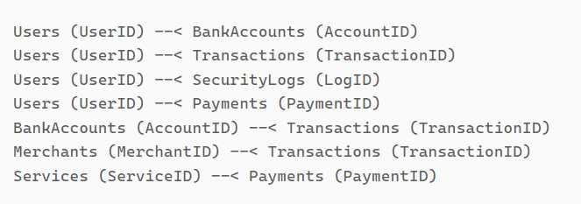

# ER Diagram:

Let's create an ER (Entity-Relationship) diagram that clearly shows the relationships and attributes of the entities within PhonePe's schema. This diagram will help visualize the key parts of PhonePe's data model and how they interact with each other. By using this diagram, you'll better understand the connections and interactions that make up the platform's functionality.

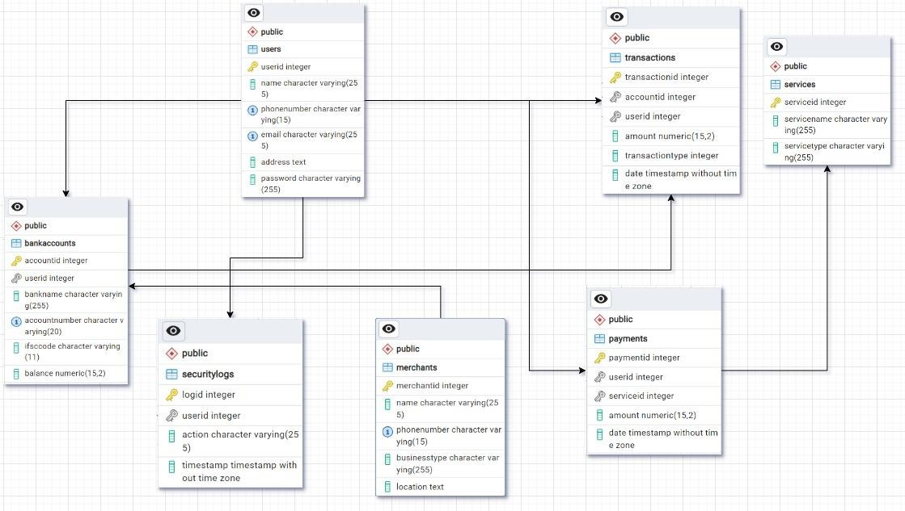

Fig: Connections between Entities

# Conclusion:

Creating an ER diagram for PhonePe's schema offers valuable insights into the platform's underlying data structure and its complex interactions. By visualizing key entities such as users, posts, comments, likes, and followers, we can better understand how data flows and connects within PhonePe. This diagram not only simplifies the comprehension of PhonePe’s data model but also

highlights the importance of each component in maintaining the platform’s functionality. Ultimately, the ER diagram serves as a powerful tool for analysing and optimizing the efficiency and scalability of PhonePe’s database design, ensuring a seamless user experience.